Papers written by
Australian Maths Software

YEAR 11
2016

REVISION 2

MATHEMATICS
SPECIALIST
UNITS 1 & 2

SEMESTER TWO
SOLUTIONS

SECTION 1 – Calculator-free
Question 1 (7 marks)
(a) Any matrix in the form 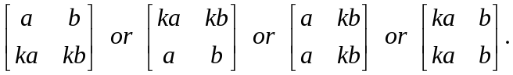 ✓✓
(b) 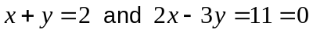
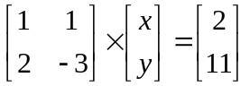
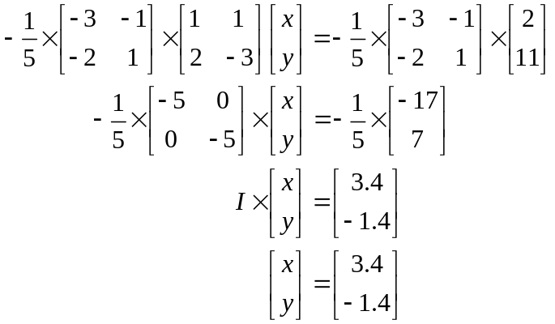
✓

✓

✓

✓

The point of intersection of the two lines is (3.4, -1.4).
(c) 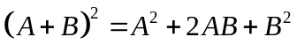is not valid if the two matrices are not commutative (which is
usually the case). i.e. if  ✓✓
Question 2 (17 marks)
(a) (i) 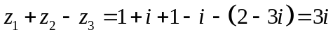 ✓
(ii) 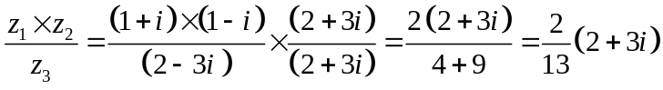
✓

✓

(iii) 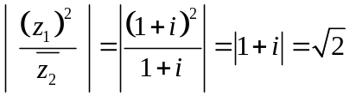
✓

✓

(iv) 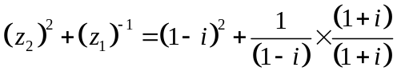
✓

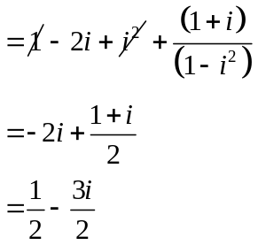
✓

✓

(b) (i)
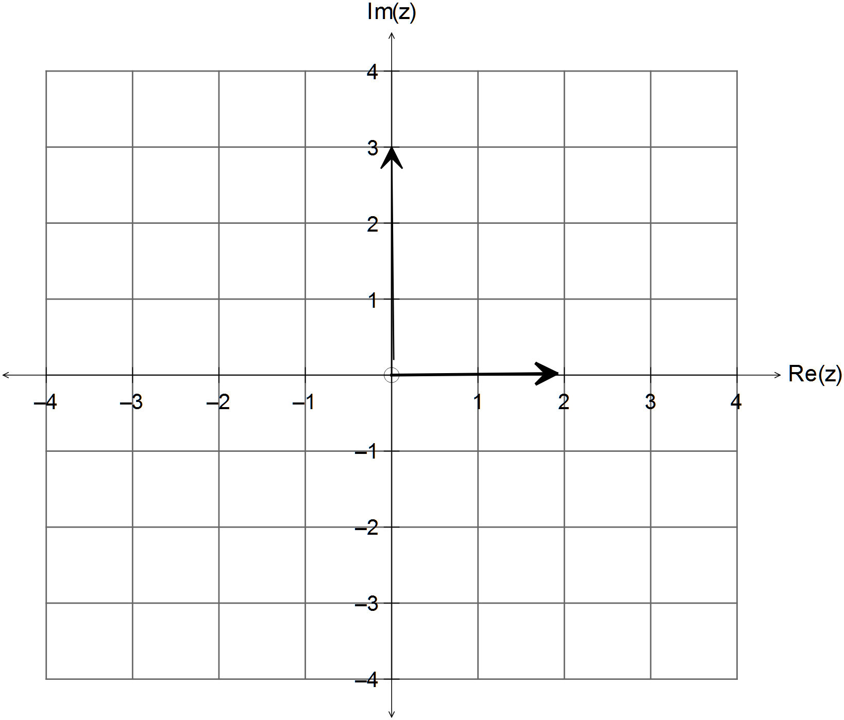
✓✓

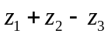
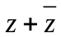
✓✓

(c) 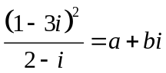
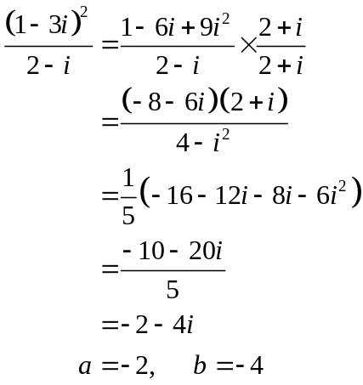
✓

✓

✓

✓

Question 3 (5 marks)
(a) 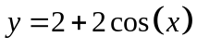
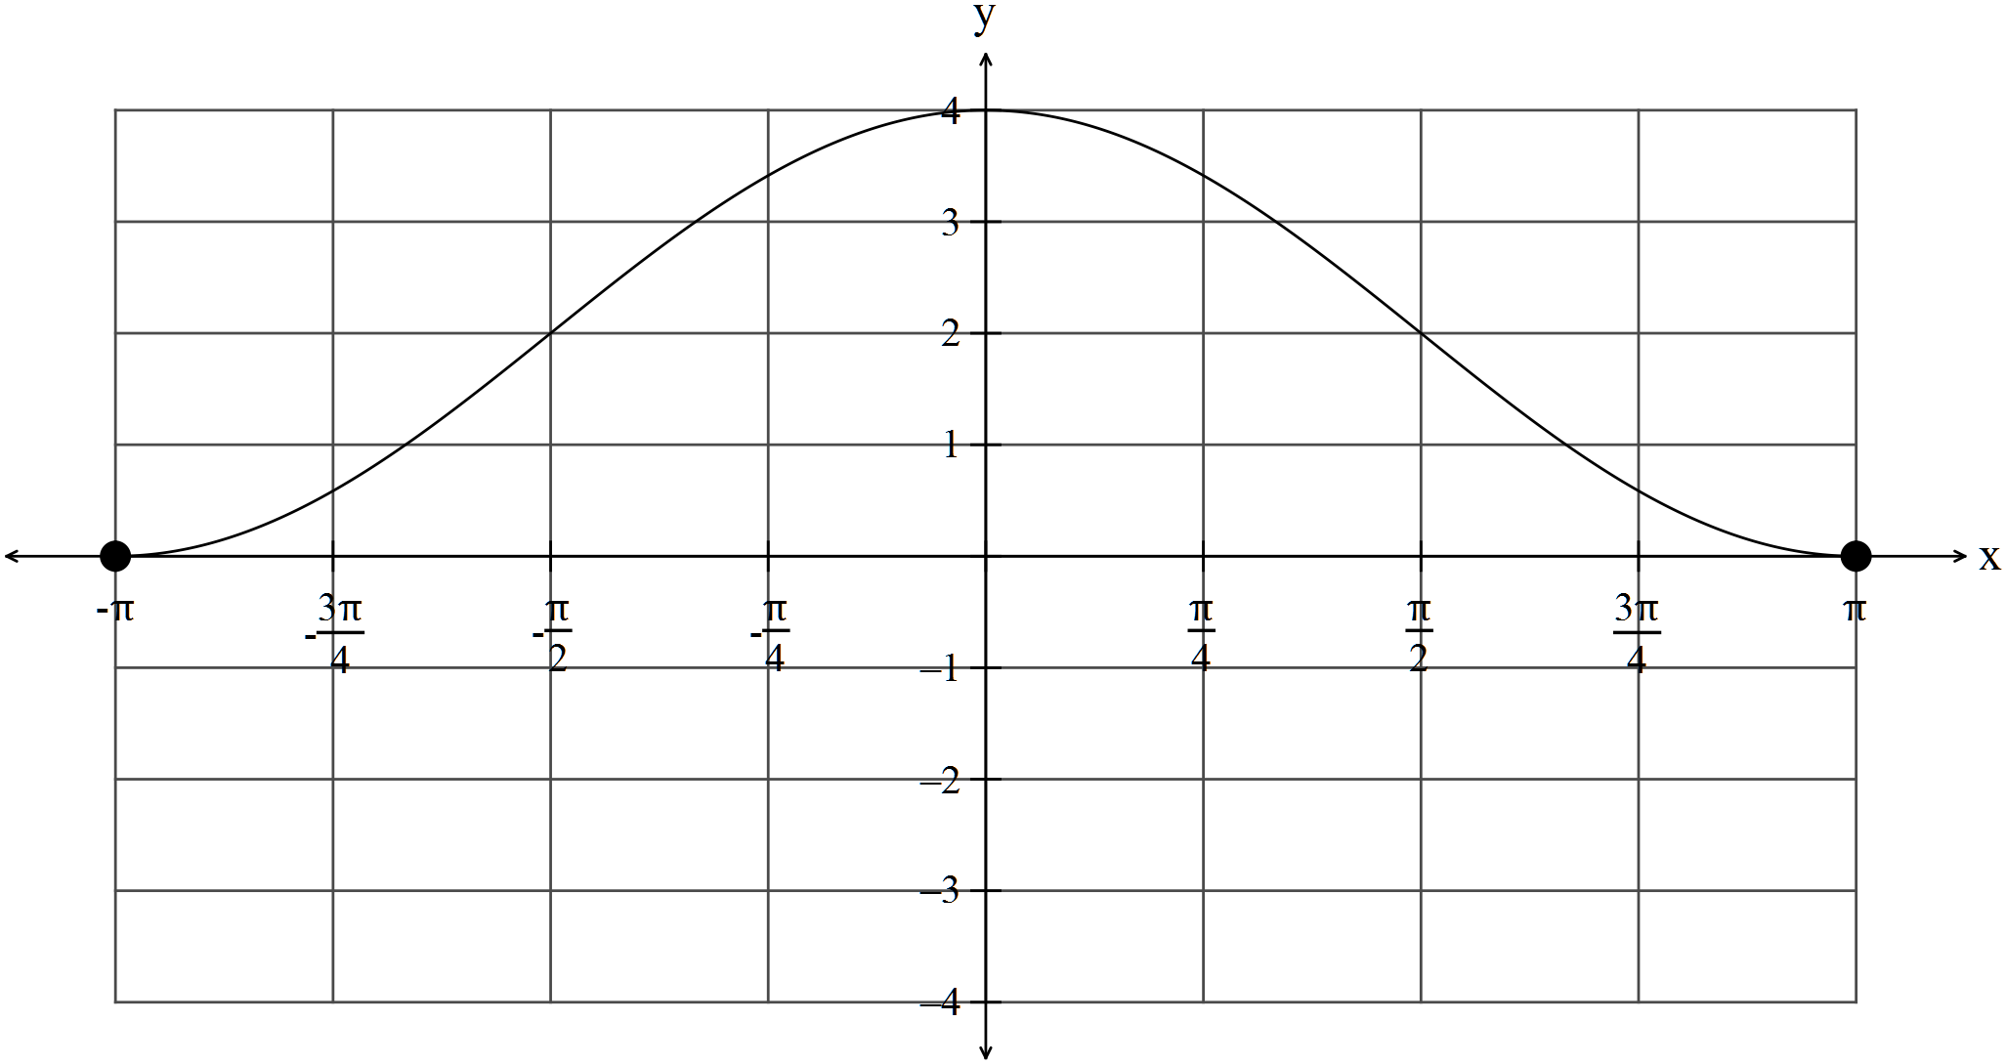
✓✓✓ -1/error

(b) 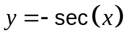
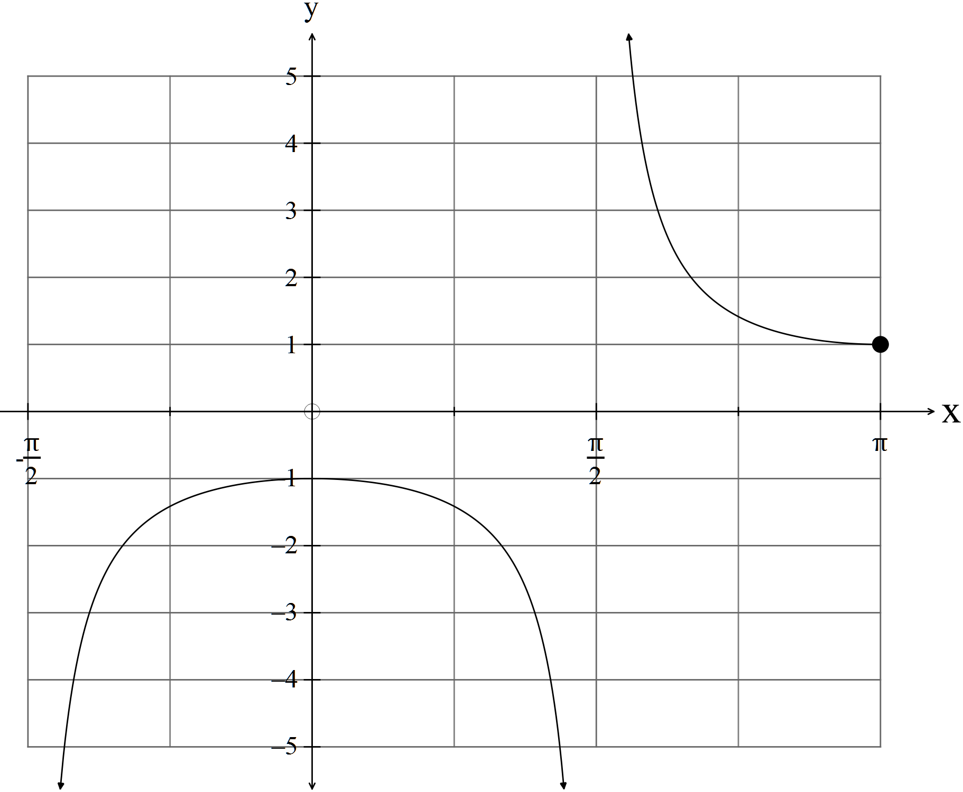
✓✓ -1/error

Question 4 (6 marks)
(a)
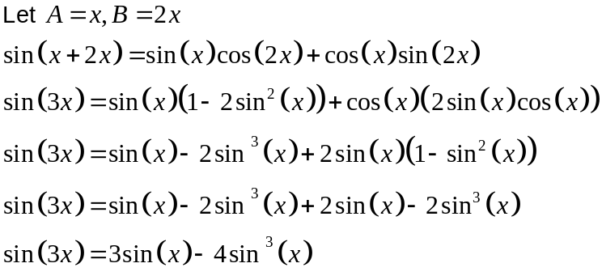
✓

✓

✓

(b) Solve 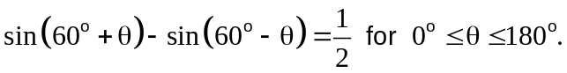
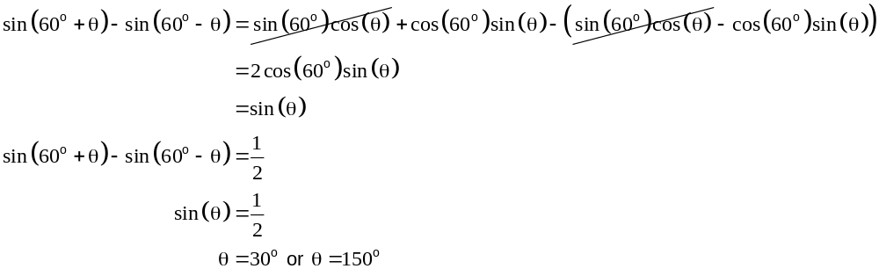
✓

✓

✓

Question 5 (9 marks)
Given the points .
(a) (i) 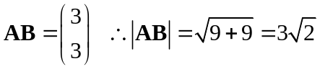
✓

(ii) 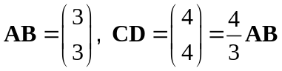
✓



(iii) 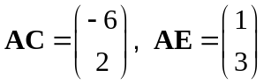
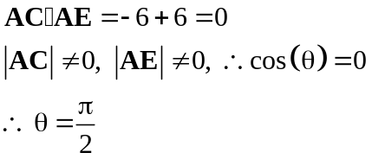
✓

(b) (i) 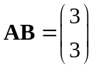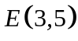
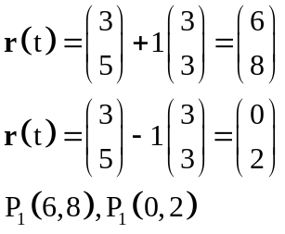
✓

✓

(ii) 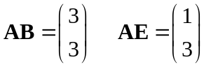
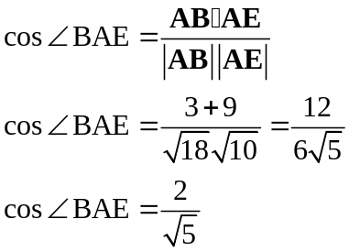
✓

✓

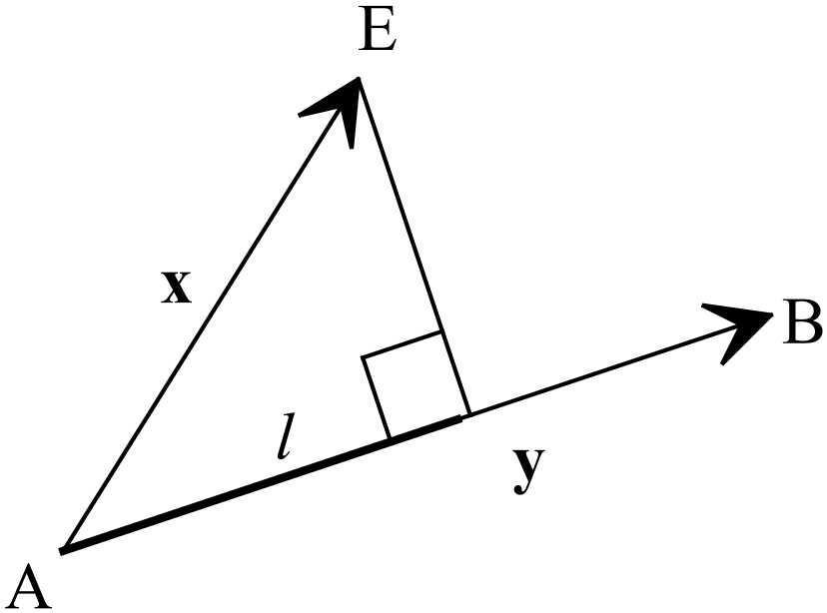(iii) 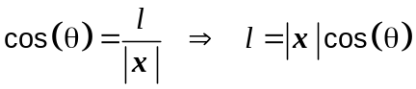
✓
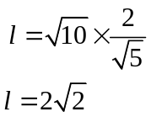
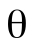
✓

Question 6 (8 marks)
(a) Deductive reasoning is when a conclusion follows as a direct consequence of the
previous statements.
✓

(b) Prove that “Angles at the circumference of a circle subtended by the same arc are equal”. (3)
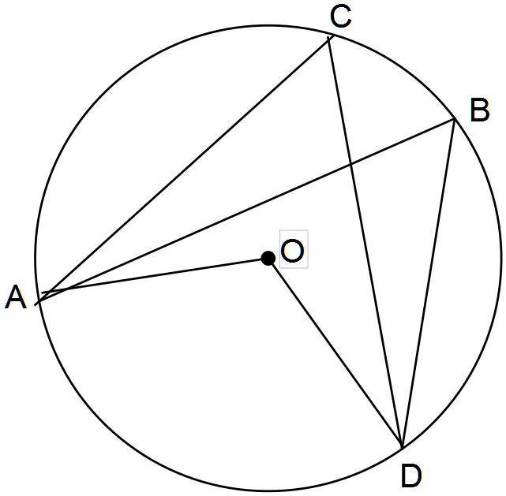
Join .

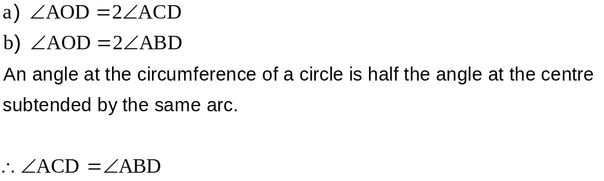
✓

✓

✓ for reason

Therefore
“Angles at the circumference of a circle subtended by the same arc are equal”.

(c) Prove the following using vectors:
“If the diagonals of a quadrilateral bisect each other,
then the quadrilateral is a parallelogram.”
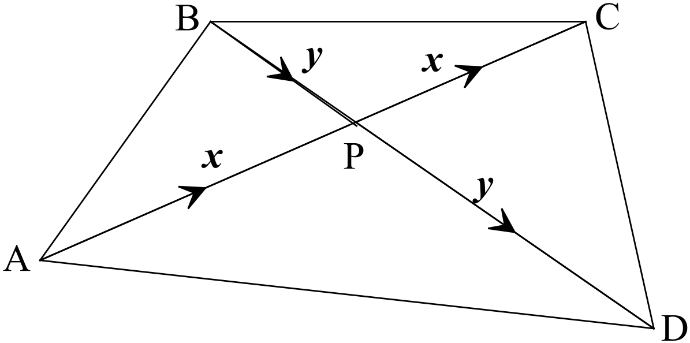
✓

Let 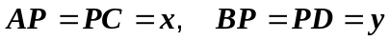.
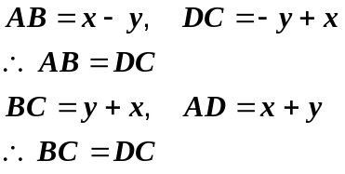
✓

✓

Two pairs of equal and parallel sides as equal vectors. (One is enough!)
✓ for reason

Therefore ABCD is a parallelogram.
SECTION 2 – Calculator-assumed
Question 7 (7 marks)
(a) If you pick five cards from a standard deck of 52 cards, then at least two will be of the same suit.
✓
Each of the first four cards can belong to four different suits. The remaining card must be the same suit as one of the other four.
✓
✓
(b) (i) 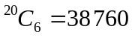
(ii) 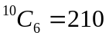
✓

(c) 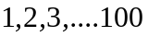
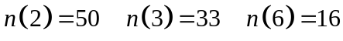
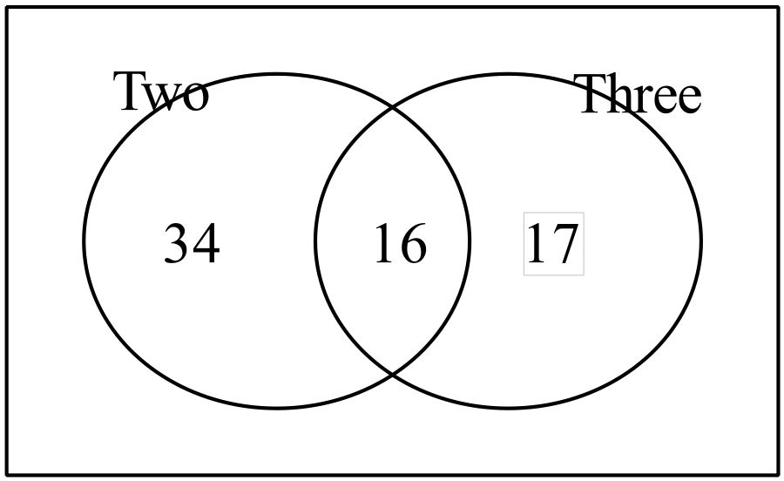
✓✓

✓
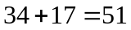
Therefore 51 of the counting numbers from 1 to 100 have both a factor of 2 or 3 but not a
factor of 6.

Question 8 (9 marks)
(a) 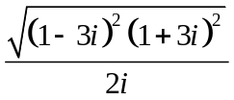
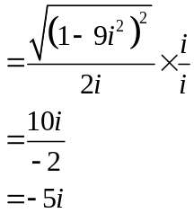
✓
✓
✓
(b) 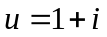 and 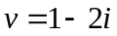
(i) 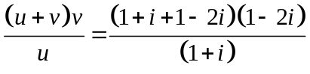
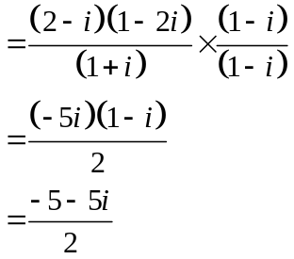
✓
✓

(ii) 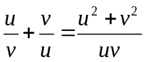
✓
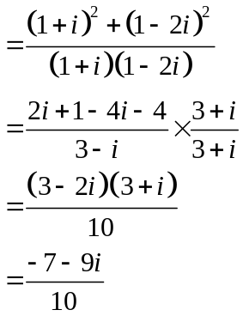
✓
✓

Question 9 (4 marks)
(a) 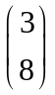+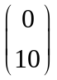+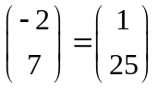
✓✓

(b) Magnitude 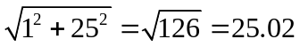
✓
Direction 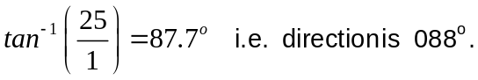
✓

Question 10 (6 marks)
(a) Solve for and
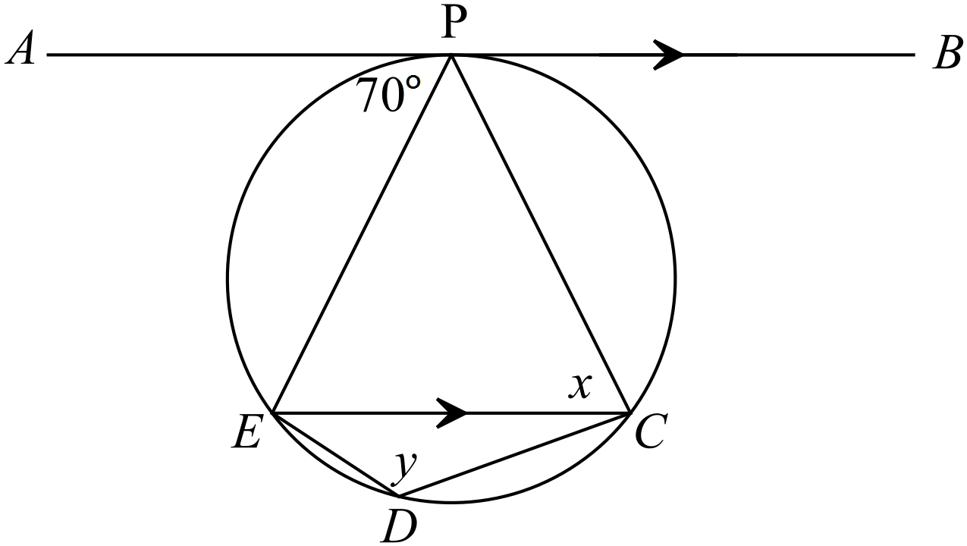
✓
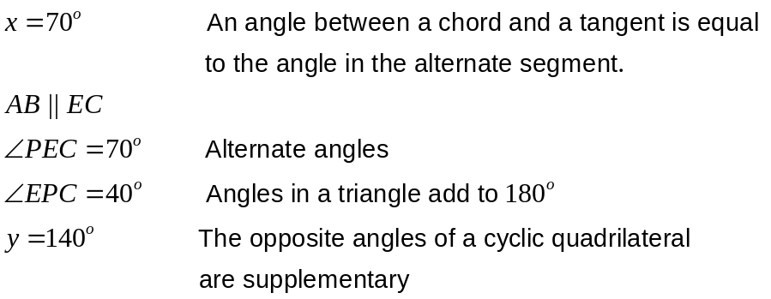
✓
✓ Reasons

(b) Solve for and
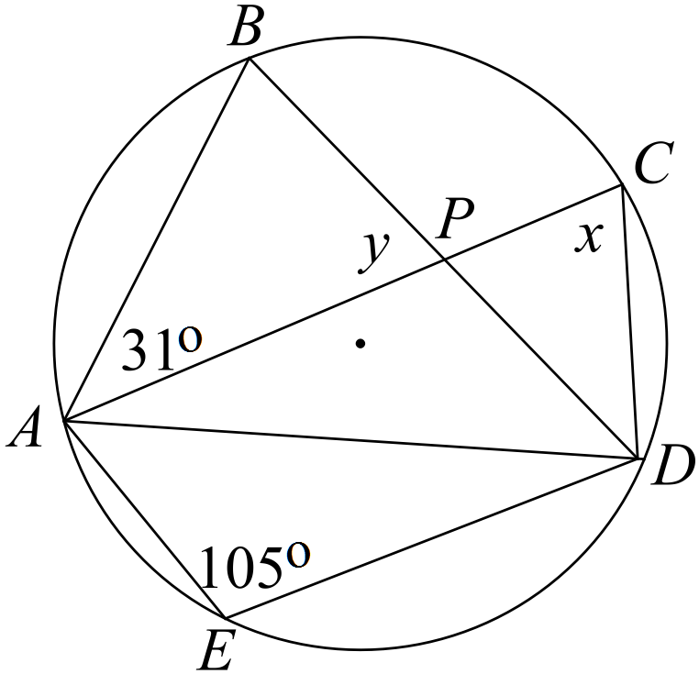
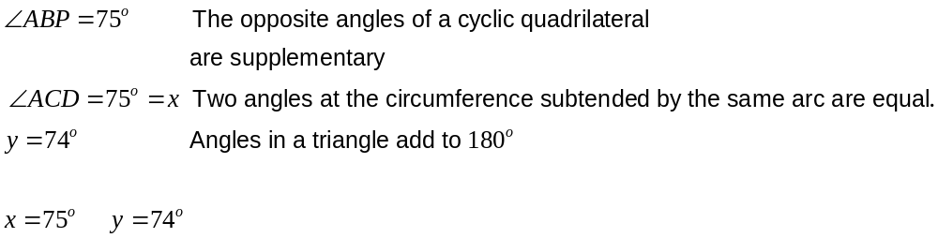
✓
✓
✓ Reasons
Question 11 (13 marks)
(a) (i) 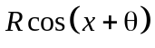= 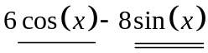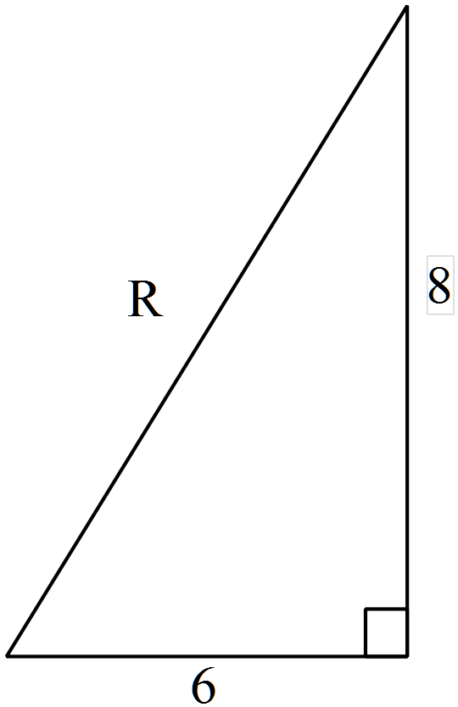
✓
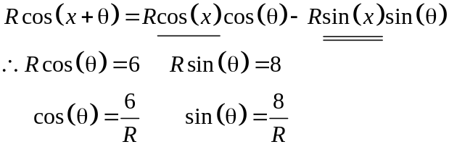
✓
Pythagoras 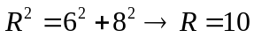
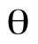
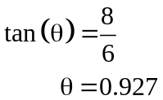

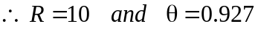
✓
✓

(ii)
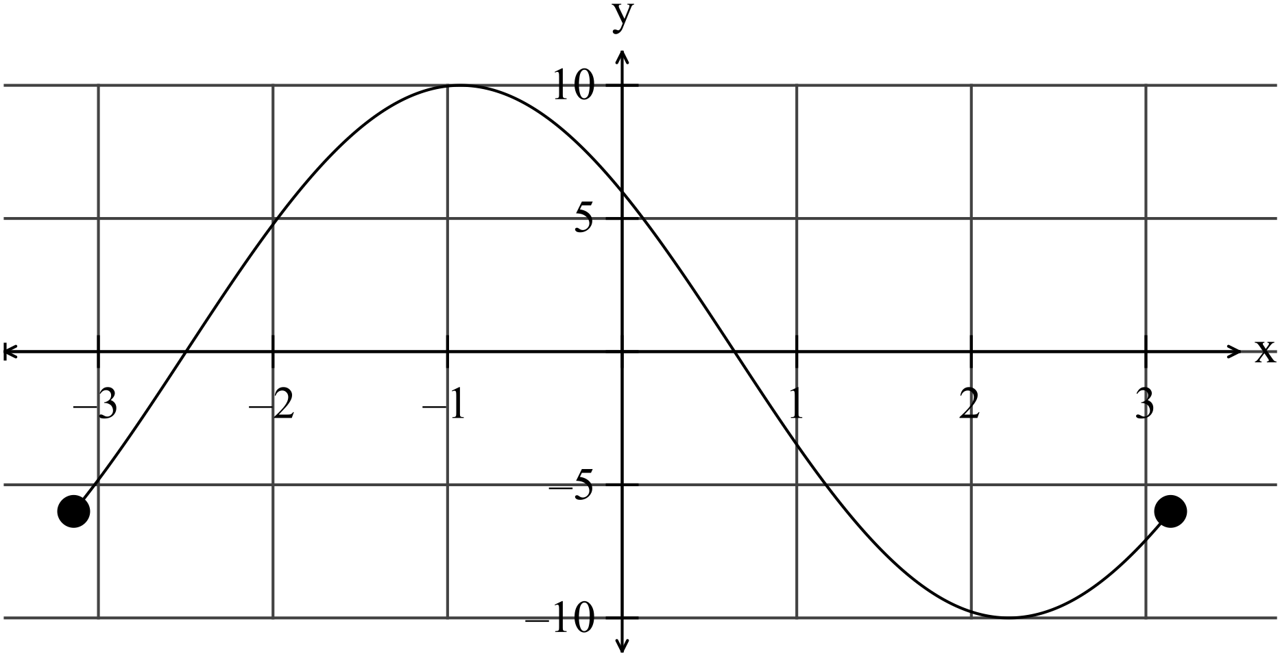
✓✓

(b) 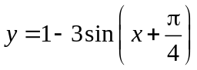
✓ ✓ ✓

(c) 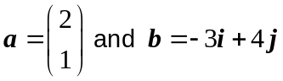
(i) 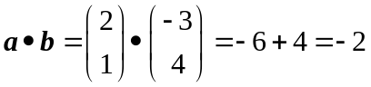.
✓
(ii) 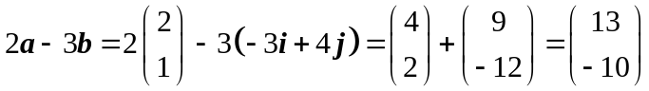
✓✓

(iii) 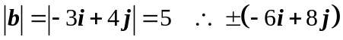
✓
✓
Question 12 (8 marks)
(a) 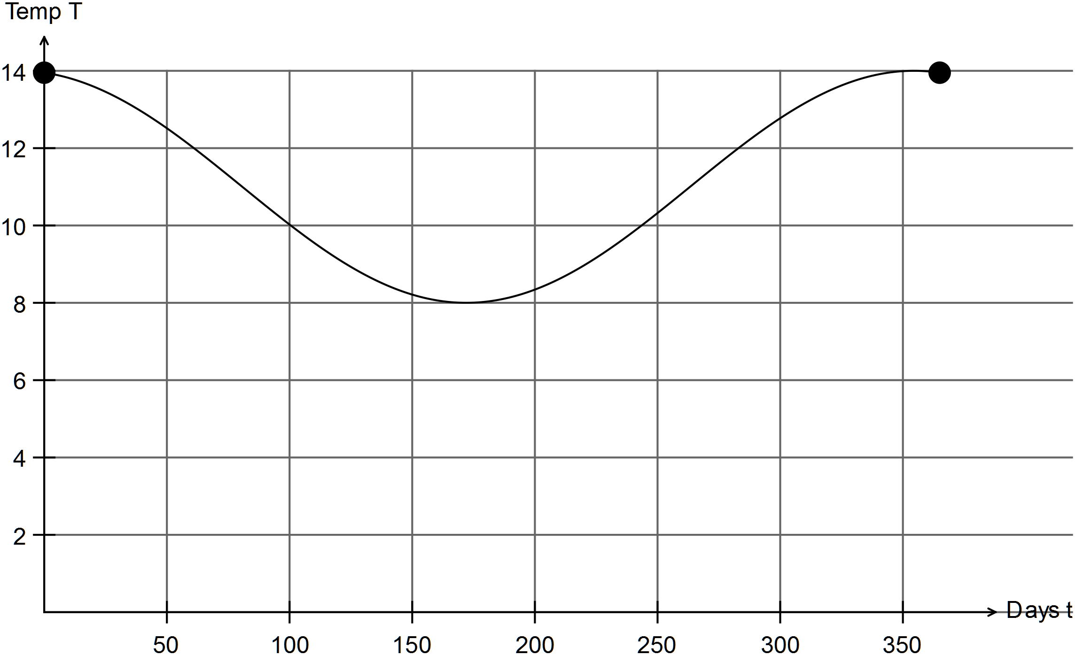
✓✓✓✓

(b) January 31
February 28
✓

March 31 90
✓

At t = 90, L = ? L = 10.524 hours of daylight on March 31st

(c) 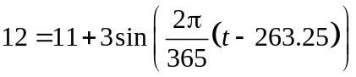
✓

Intersection at t = 61 and t = 283
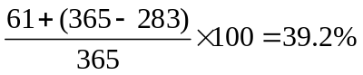
✓

About 39% of days have
Question 13 (3 marks)
Prove 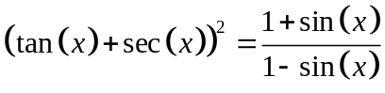
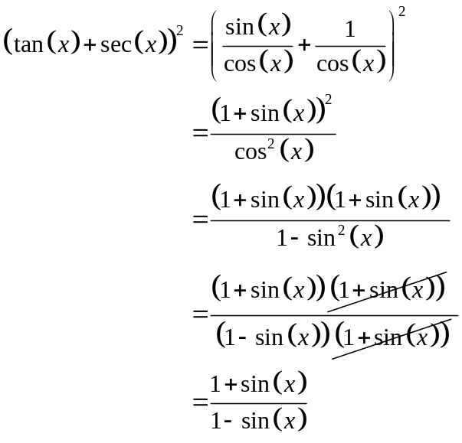
✓
✓
✓

Question 14 (10 marks)
(a) 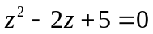.
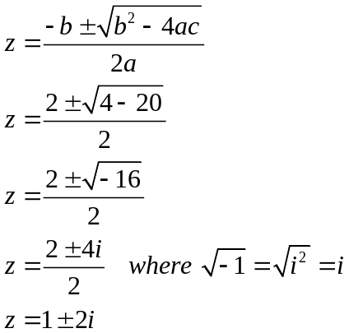
✓

✓
✓
✓

✓
✓✓

(b) 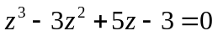
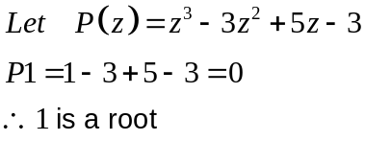
✓

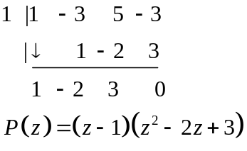
✓
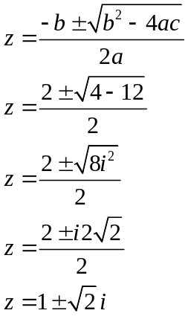

✓
✓

✓
✓

(c) (i) Given 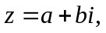 prove that 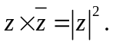
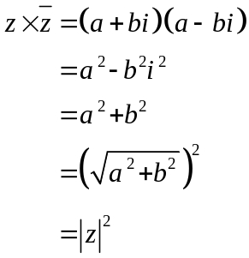
✓
✓
✓
(ii) 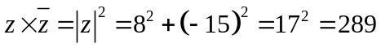
✓
Question 15 (9 marks)
✓
(a) “If Susan does not buy some avocados, then they do not cost less than $4.”
✓
(b) The converse is “If Terry sits outside with his coffee, then today is a sunny day.”
(c) Prove 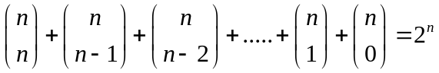
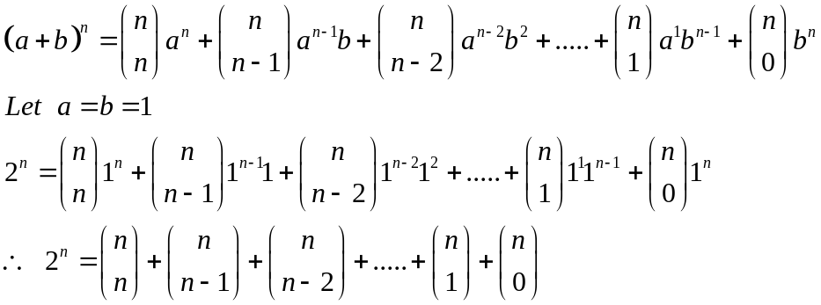
✓
✓
✓
(d) Use the method of proof by contradiction to prove that there are no positive integer
solutions to the Diophantine equation 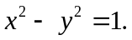
NB A Diophantine equation is an equation for which you seek integer solutions.
. Assume that there is a solution 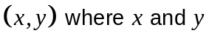are positive integers.
✓
Factorise the left side: 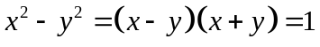

Since 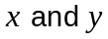 are integers, it follows that either.

If 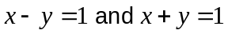 then we can add the two equations to get x = 1 and y = 0, contradicting our assumption that x and y are positive.
✓
✓
If 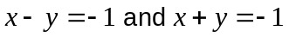, we get x = -1 and y = 0, again contradicting our assumption.
✓
Therefore our assumption that there is a solution (x, y) where x and y are positive integers is invalid.
✓

Therefore there are no positive integer solutions to the Diophantine equation
Question 16 (13 marks)
ABCD is a parallelogram. A linear transformation given by 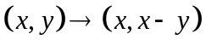 that
(a) (i) 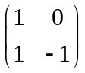
✓✓

(ii) B(2, 0) C(3, 1)
✓

A(0, 0) D(1, 1)
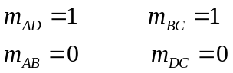
✓
Two pairs of parallel sides so parallelogram.

(iii) 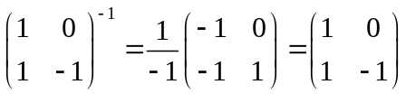
✓
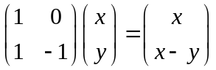
Yes, A’B’C’D’ can be transformed back to ABCD using .
✓
(b) (i) 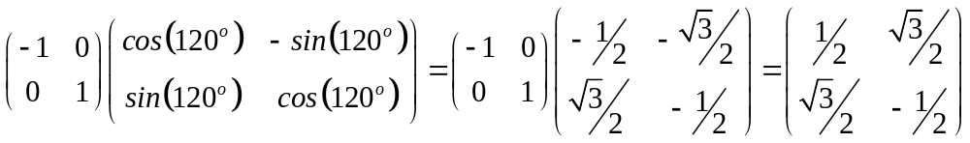
✓
✓
✓

(ii) 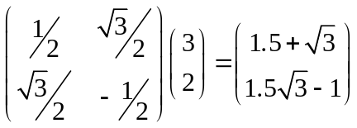
✓
✓

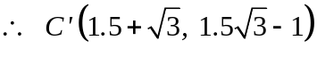

(iii) 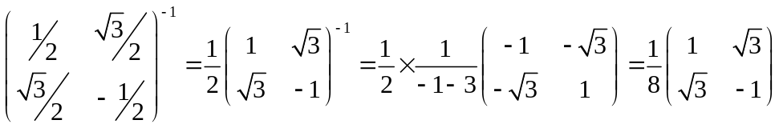
✓✓ -1/error

Question 17 (8 marks)
It is known that the matrix M performs a reflection about the line 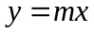
where

(a) 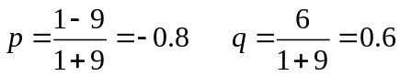
✓
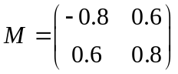
✓

(b) 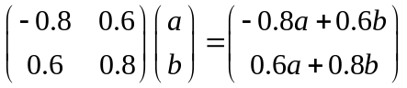
✓
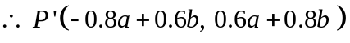

(c) Let be the matrix that reflects a set of points about a line that contains the origin.

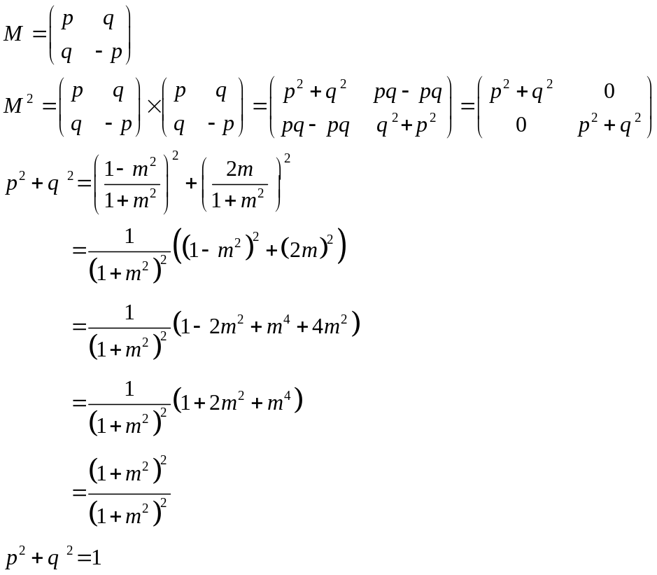
Therefore 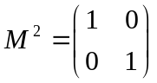 so the points end back where it started.
i.e. a reflection of a reflection is itself (about a line containing the origin) .

Question 18 (8 marks)
(a) 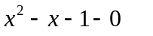
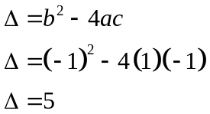
✓

The roots are irrational.

(b) Prove using mathematical induction, that 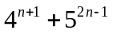 is divisible by 21
Test for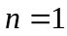.
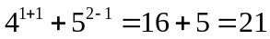
✓

So divisible by 21 for .
✓

Assume valid for i.e. that 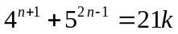

Test for 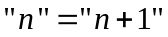
✓

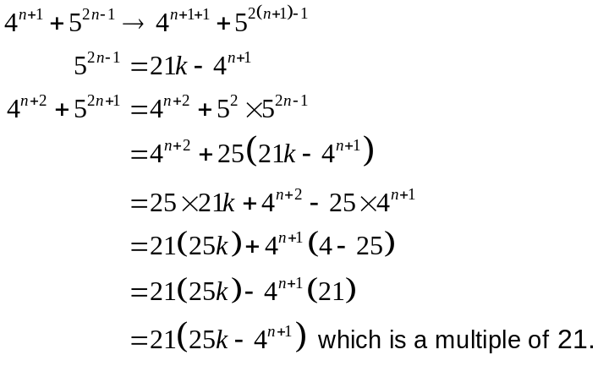
✓

✓

✓

So, if valid for n, then valid for n+1.
Valid for n = 1, so valid for n = 2 etc.
✓

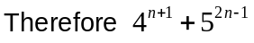 is divisible by 21.

End of solutions

